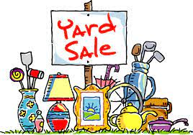
From now until May 31st, St. Andrew’s is holding an online Yard Sale. We are looking for donations of the following items:
- Small appliances
- Toys in good condition (not plush)
- Tools
- Jewelry
- Furniture
- Linens
- Artwork
- Collectibles
- Other items
For more information contact: Janette 634-8009 or Josie 634-3919

